Confirmation of discussion Financial Relief  Date: |  | 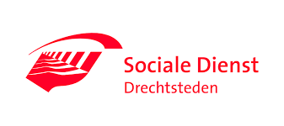
Today we discussed how the monthly costs for your home, such as rent, electricity and gas, and your health insurance will be paid over the next six months.

For this purpose, we use your income from Drechtsteden Social Services, the allowances from the tax authorities and other income, for example from employment.
From this income, the monthly costs for rent, energy, water and health insurance are paid. The loans from Drechtsteden Social Services are also repaid for the costs of the initial rent and for furnishing your house.
This is stipulated in the Participation Act in section 56a. It is called Financial Relief.
The remaining money is paid out each month as living expenses
.

Personal particulars
BSN number:
Surname:
First names:
Date of birth:
Street name and number:
Postal code and place of residence:

Income
Description: | Benefit Drechtsteden Social Services
Other income if applicable:

Signature
Place …..............................................

Date …………………………………..

Signature of holder of residence permit ……………………………………

